Communications Assistant Job Pack
Salary: £25,300—£27,500 gross per year
(dependent on experience)
Contract Type: Permanent
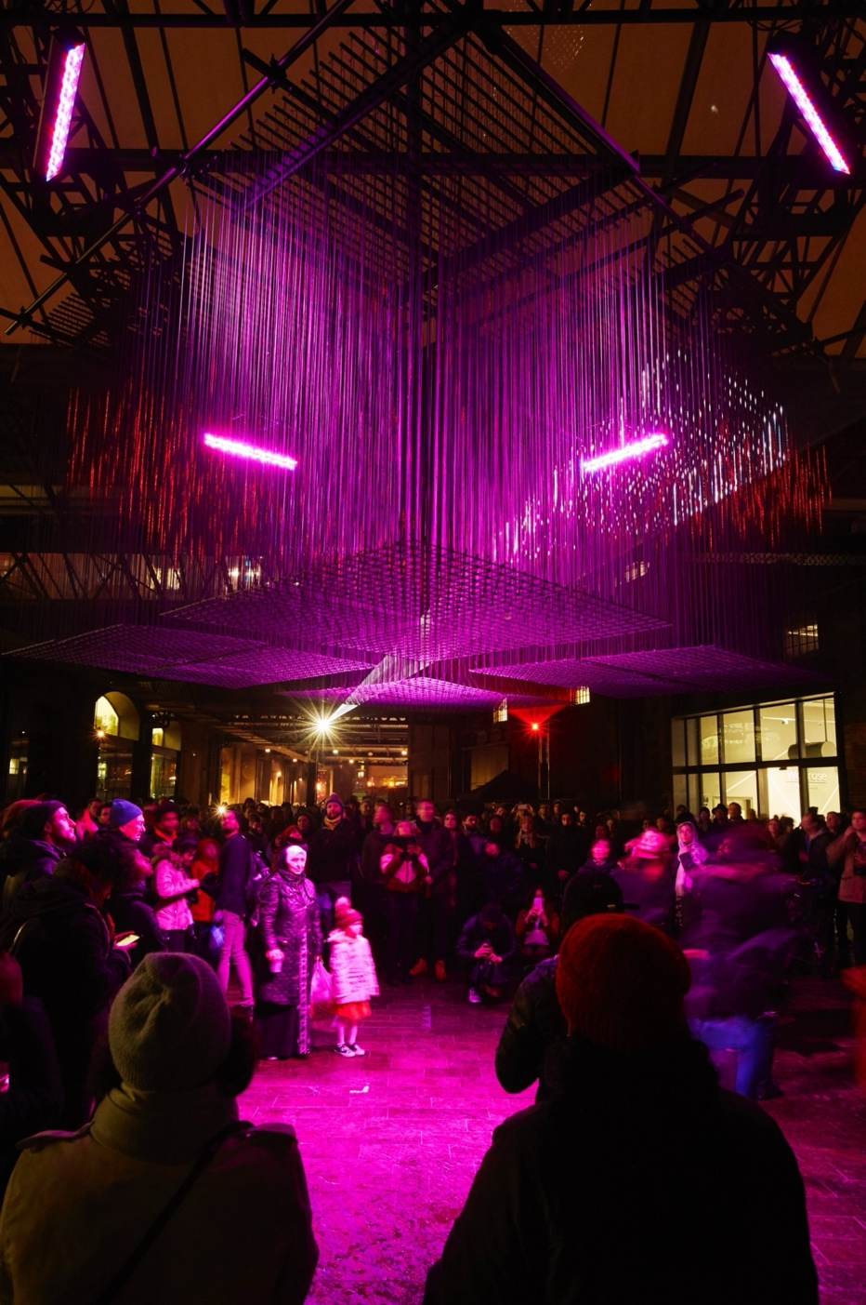
Full-time, five days per week
‘Aether’ by Architecture Social Club with Max Cooper, West Handyside Canopy, King’s Cross.
Lumiere London 2018, 18 - 21 commissioned by the Mayor of London. Photo by Matthew Andrews

Summary of Terms & Conditions
Job Title: Communications Assistant
Reports to: Digital Communications Manager
Location: London, E1 6AB. Office-based Monday to Thursday with an optional work-from-home day on Friday. Some travel around the UK will be required on occasion.
Salary: £25,300—£27,500 gross per year (dependant on experience)
Contract: Permanent
Probationary period: Three months
Notice period: Three months (two weeks during the probationary period)
Hours of work: 35 hours per week, Monday to Friday, 10am-6pm, with some variation according to the nature of the workload. Additional hours may occasionally be required as necessary for the successful performance of the job.
Annual leave: 25 days per year plus bank holidays. An additional day of annual leave is granted for each year of employment (up to five years).

Company Background
Artichoke was founded in 2005 to bring The Sultan’s Elephant by Royale de Luxe to central London. For the first time, streets normally reserved for state occasions or sporting events were taken over by art. The Elephant changed the landscape for outdoor art forever and catapulted Artichoke into the public eye.
The company has continued to work with artists ever since, with the aim of producing unique, large-scale experiences that appeal to the widest possible audience. We don’t believe the arts should only take place behind the closed doors of theatres, concert halls or galleries. Instead, you will find our events in the street, public squares, along the coast or in the countryside.
To learn more about our past projects, visit our projects page.

Overview of the Role
Artichoke is seeking a fast-learning and organised Communications Assistant to join our busy London-based team. The ideal candidate is passionate and driven, with an interest in arts & culture communications, a particular passion for social media, a thirst for learning and keen eye for detail. As a supporting position to the whole Communications (Marketing & PR) team, this role offers the opportunity to develop varied experience of all aspects of arts communications. This role will suit someone who would like to develop a career in the arts, has a knowledge of social media, and who will rise to the challenge of working in a fast-paced, creative environment.
The Communications Assistant will be an important colleague in helping to implement Artichoke’s communications strategy, providing core support to the Communications team. You will take specific responsibility for some of the essential communications tasks including media monitoring, the maintenance of Artichoke’s image library, and social media engagement.

How to Apply
- Read the information in the Job Description & Person Specification on the following pages.
- Fill out our application form. Ensure you give specific examples to support your claims in the personal statement.
Application deadline: 10am, Monday 10 March
Interview dates: First-round interviews to take place remotely on Teams w/c 24 March. Second-round interviews to take place in person at Artichoke’s office (E1 6AB) w/c 31 March.
Start date: Immediate start, depending on the notice period
Artichoke is an Equal Opportunities and Disability Confident Committed employer. We are committed to equality and diversity within our workforce and encourage applications from People of Colour, d/Deaf and disabled people, and those from underrepresented backgrounds. Positive action may be used in the recruitment process to select a candidate from a group that is disadvantaged or underrepresented in our workforce if the candidates in question are of equal merit.
If you require this job pack in an alternative format, please email us at recruitment@artichoke.uk.com or call on 020 7650 7611.

Job Description
The following sets out responsibilities you will hold in this position but is not a comprehensive or exhaustive list. Our projects are varied and require different ways of working, and responsibilities will adapt based the needs of the organisation.

Key Responsibilities
- Act as the main point of contact for Artichoke’s media monitoring service, track press coverage, circulate a weekly clippings update, maintain the press cuttings archive and produce reports where required.
- Support the Communications team with research requirements, including media and marketing campaign research and Artichoke sponsor research in terms of benefit support and delivery.
- Monitor, track, analyse, and report on performance on social media platforms, using tools such as Instagram & Facebook Insights to produce reports of digital activity for each Artichoke project.
- Take responsibility for logging key data, including social media performance metrics and media coverage.
- Research and identify visual arts and culture websites and social media channels to collaborate with to direct audiences to Artichoke channels.
- Work closely with the Communications Coordinator to manage and maintain the Artichoke image archive and work with Artichoke’s press team to respond to media image requests.
- Support the Communications team with print requirements.

General Requirements of all Artichoke Employees
- Contribute to the development of a professional working and learning environment within the organisation.
- Contribute to the organisation’s understanding of diversity and its implications for the arts and to ensure that this understanding informs all the organisation’s activities.
- Attendance and minute-taking at key strategic meetings where required.
- Support and attendance at fundraising and press events where required.
- Ensure adherence to the organisation’s policies and procedures with particular reference to Equal Opportunities and Health and Safety.
- Work in a flexible manner in line with the organisation’s corporate objectives and be willing to undertake other duties as reasonably requested.
- Provide excellent customer care in dealings with the public.

This job description is not exhaustive, and the post holder may be required to undertake other such duties from time to time.

Person Specification
Essential | Desirable
A minimum of six months’ experience in a communications/marketing role gained through a previous or current job, an internship, or volunteering. | Some spoken and written knowledge of other languages would be beneficial.
A passion for social media and its possibilities. | Knowledge of Adobe Suite or desire to learn.
Some experience and knowledge of social media management and campaigns.
Excellent copywriting skills.
Proven administrative and organisational skills.
Familiarity with software packages including word processing, spreadsheets, databases, email and the internet.
Demonstrable interest in the arts and Artichoke as an organisation.
An ability to work independently, flexibly and proactively in a high pressure and fast-paced environment.

Additional benefits
Pension: Artichoke is enrolled in a pension scheme with Standard Life. After working for Artichoke for 3 months, payments of 3% can be made into your pension if you contribute 5% of your qualifying earnings.
Group Income Protection (GIP) Insurance: Artichoke’s GIP policy will pay employees a percentage of their salary if they can't work due to long-term injury or illness.
Employee Assistance Programme (EAP): A confidential, employer-paid benefit offering support and advice on personal and work-related issues, including stress, financial worries, legal concerns, and family matters.
Cycle to work scheme: Artichoke purchases the bike on behalf of the employee at a reduced retail price and saves the employee tax and NI. The cost of the bike is deducted from the employee’s gross monthly salary.
Season ticket loan: Artichoke offers an interest-free loan to staff who require a season travel ticket.
Eye tests and glasses: Artichoke offers to pay for an eye test every year for staff members, up to £30, and for prescription glasses up to the value of £150.
Other forms of leave: Artichoke offers enhanced parental leave and a paid sabbatical for staff who have worked at Artichoke for a minimum of one and five years respectively.
If you have any questions about the role, please email us at recruitment@artichoke.uk.com or call on 020 7650 7611.

