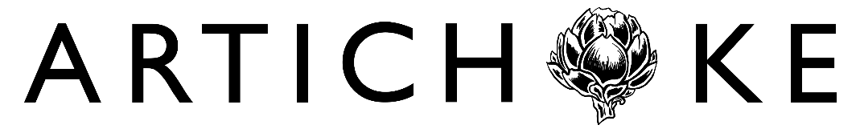
Tips for the Personal Statement
We’ve compiled some tips to help your personal statement stand out and increase your chances of being offered an interview. This advice is based directly on the job applications that we've received in the past.
- We like a personal, tailored approach. We want to know that you’ve thought about what we do and what the job would entail. We like to see that you’ve researched Artichoke in particular, rather than write a generic application that could be made to any arts company. To learn more about our past projects, visit our projects page.

- As a minimum requirement, we look for people who show a genuine interest in Artichoke’s work. Successful candidates should demonstrate that they have researched or experienced previous Artichoke projects and understand the impact of our work in the public realm. We like to see that you’ve made your application relevant to us by referencing our work and pointing out why you’ve been inspired to work for us.

- We discourage the use of generative AI programs (such as ChatGPT) to write any part of your application. When we receive large numbers of applications that seem to be using the same words, phrases or idioms, we tend to immediately disregard them.

- We look for evidence of clear thinking and excellent communication skills. Make sure that your application is accurately proofed and spell-checked.

And, above all:

- The best personal statements make it clear and easy for us to see how your previous experience matches the essential criteria in the Person Specification. Use these criteria as a guide and address each one unambiguously in your statement. Support your claims with specific, real-world examples. A well-written personal statement that addresses the essential criteria and references Artichoke will give you the best chance of being selected for interview.

